**APPLIED CRYPTOGRAPHY**

NAME: VISHWAS M

SRN: PES2UG20CS390

SEC: F

LAB: Hash Length Extension Lab

Task1: Send Request to List Files

Step1: Finding the uid

Step2: Calculating MAC

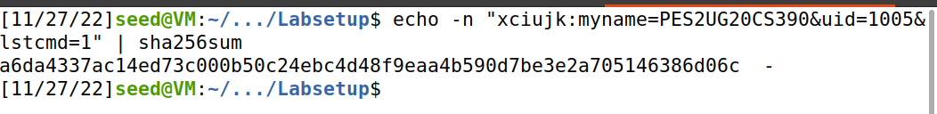

Step3: Sending the Request

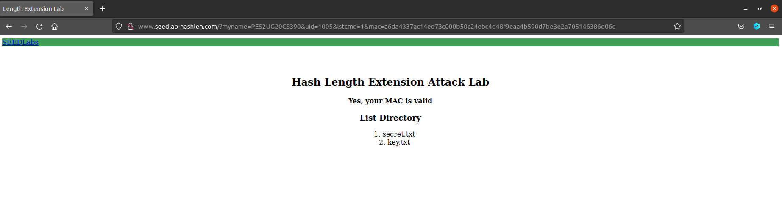

We are just finding the directory list from the above steps.

Step1: Finding uid

Step2: Calculating MAC



Step3: Sending the Request

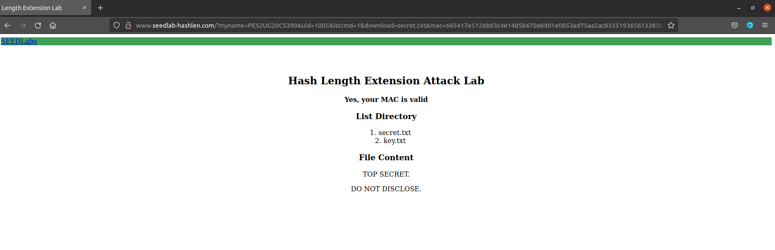

We are finding the contents from secret.text which is displayed in the above screenshots.

Task 2: Create Padding

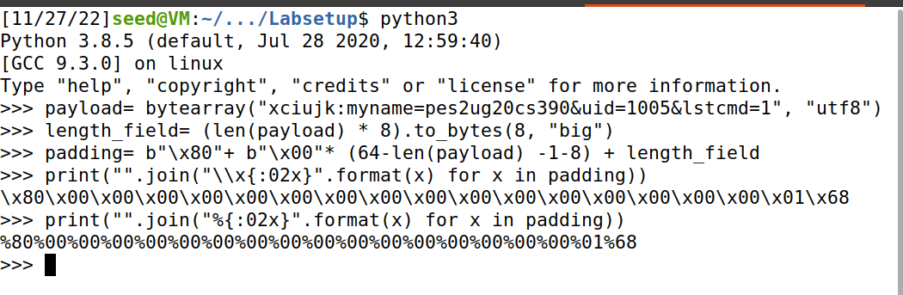

We can observe the URL and hash padding.

Task 3: The Length Extension Attack



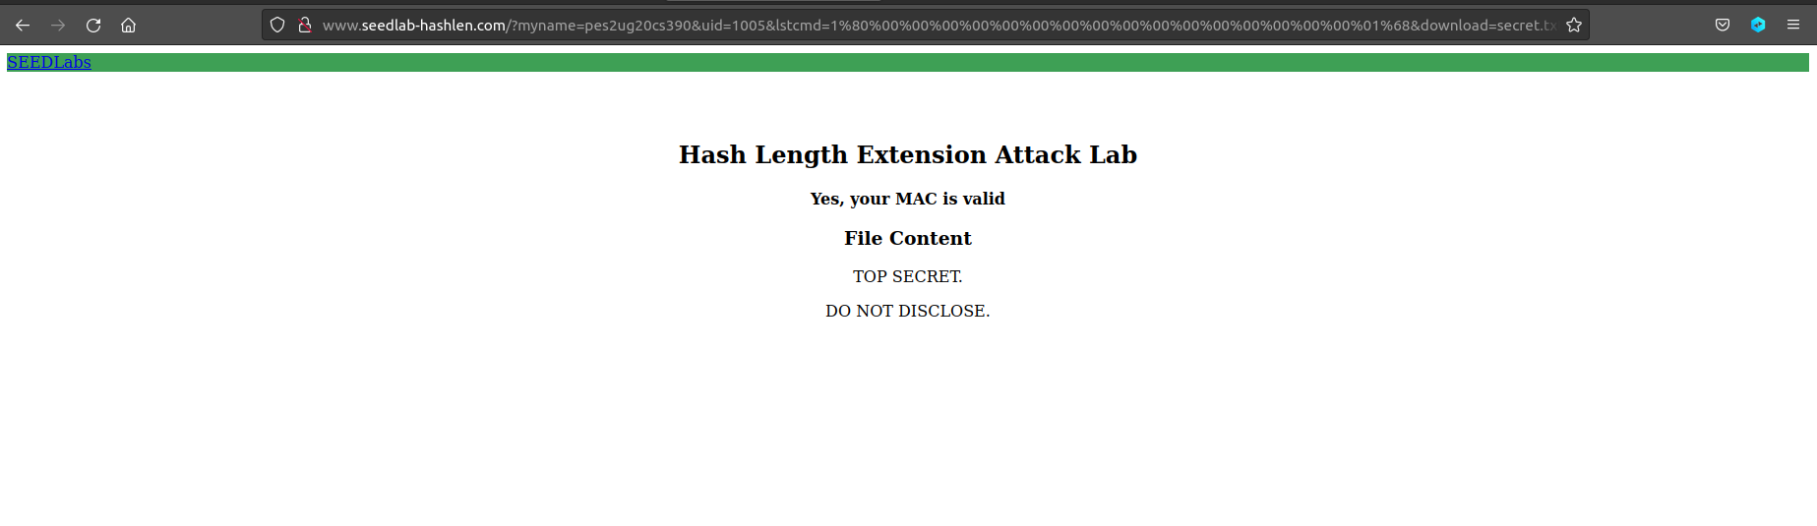

Without key:

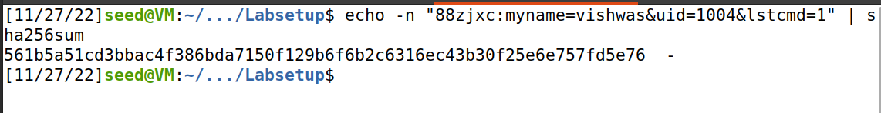

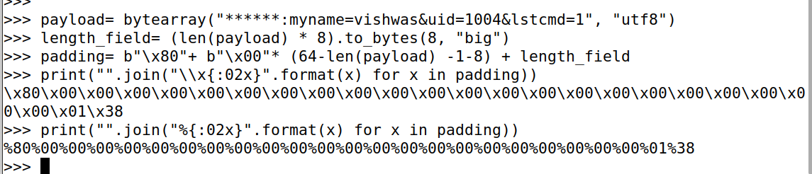

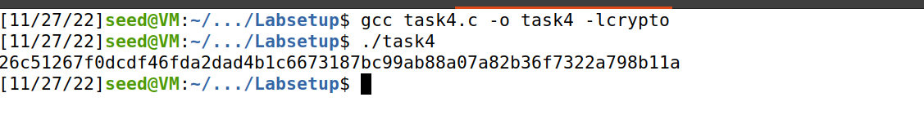

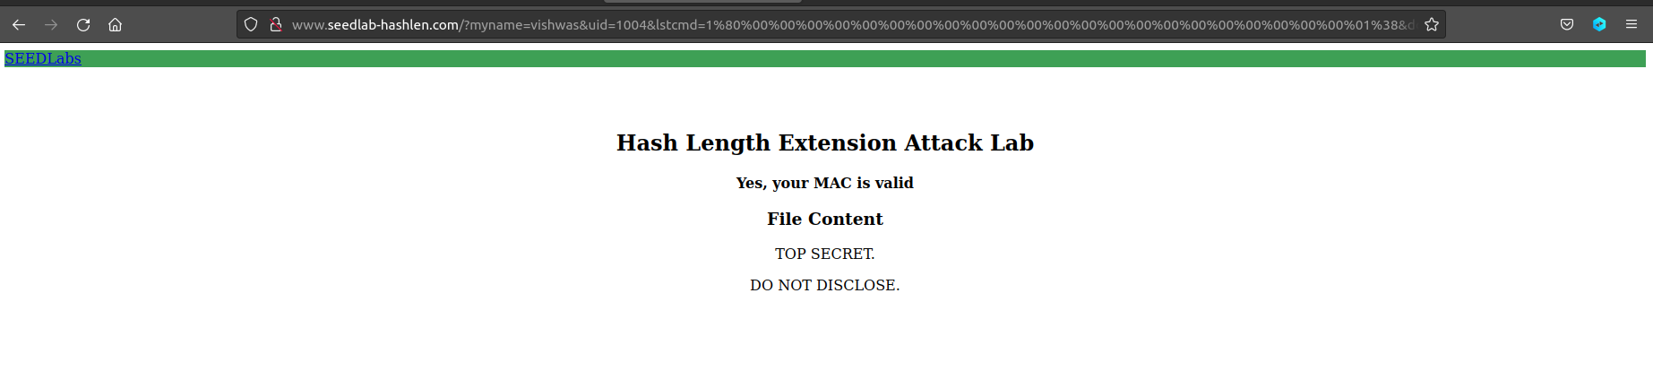

The attack is successful and we can see the contents of the file secret.txt even though it is not a valid MAC address. We do both the attacks with the key and without it.

Task4:

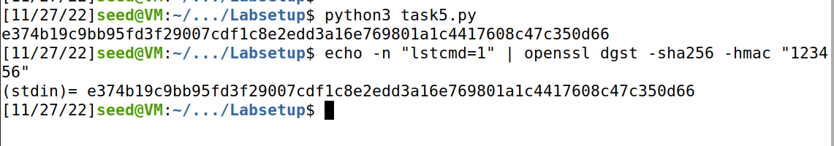

We use hmac to avoid the length extension attack as the mac generated will not be same for the extended length and the original address without padding and will thus fail to authenticate the address.